July 2019

Newsletter

Nepean Budgerigar Society
Upcoming EVENTS
Christmas in July:
Sunday 14th July @ 12pm Dingley Hotel 334 Boundary Rd Dingley RSVP asap Mim 0421085974
August Training Night :
Tuesday 20th August @ 7.45 ‘Getting your birds show ready and some tips on what the judges are looking for in some varieties’ Guest Speaker James Smith
Please see further details in this newsletter.

  - President report from John Freeman
  - Welcome to all!
  - The club held its AGM in June, and we are pleased to announce the following executive committee: President – John Freeman Secretary – Mim McQualter Treasurer – Rohan McQualter
  - We thank our outgoing committee, and welcome in our new one. The club is introducing many new initiatives moving forward, and we look forward to sharing this journey with our club members. Please spread the word among your friends. We welcome any that would like to pop along to any of our events just to be a part of them, and happy to chat to anyone interested in joining Nepean Budgerigar Society.
  - We encourage you to be involved in the events organized where you can. These events are designed to educate and encourage socialization. We have our midyear Christmas In July coming up Sunday 14/7, and a training night with James Smith on Tuesday 20/8.
“It’s all about the ‘club’ experience!”
On a lighter note…it’s great to hear that many of our members are well into breeding and doing well. I personally have not started yet due to moving house. But many members have been breeding for some time. Don is nearly out of rings already. He requested a good hen from myself to go with a cock bird he had purchased 2 weeks ago, which i loaned to him. Now he has just informed me that she is on eggs and they are fertile, must be doing something right at your place Don.

Rohan and MIm have been breeding right through the year and have had many young with some good success in both quality and quantity. I am not sure how many Steve has bred but he does assure me some very good quality young have been bred. Seems like the birds are doing bit better than Steve’s footy team (St Kilda)!

The cold well yep it sure has been chilly! I have lost a few due to the cold (mostly older birds) but that has to be expected when all your birds are in a large outdoor aviary waiting for their new bird room to be completed. Rohan having been so generous with his time over many weekends helping with this, he has been working hard to get me up and running this has been very much appreciated. Also thanks to Don and Chris who have helped out as well.

Well back to the cold. For those who have outdoor aviaries or set ups, it is very important to keep plenty of seed up to the birds at all times probably more than normal, keep them dry and be sure to use a plastic cover sheet/blinds or something similar over exposed wire or windows during the cold day’s and especially at night.

Be good and happy budgies
John Freeman

Its time for our mid year get together!
Please don’t forget to RSVP asap for booking purposes at the hotel.
Please call or text Mim on 0421 085 974 or email info@nepeanbudgerigarsociety.org

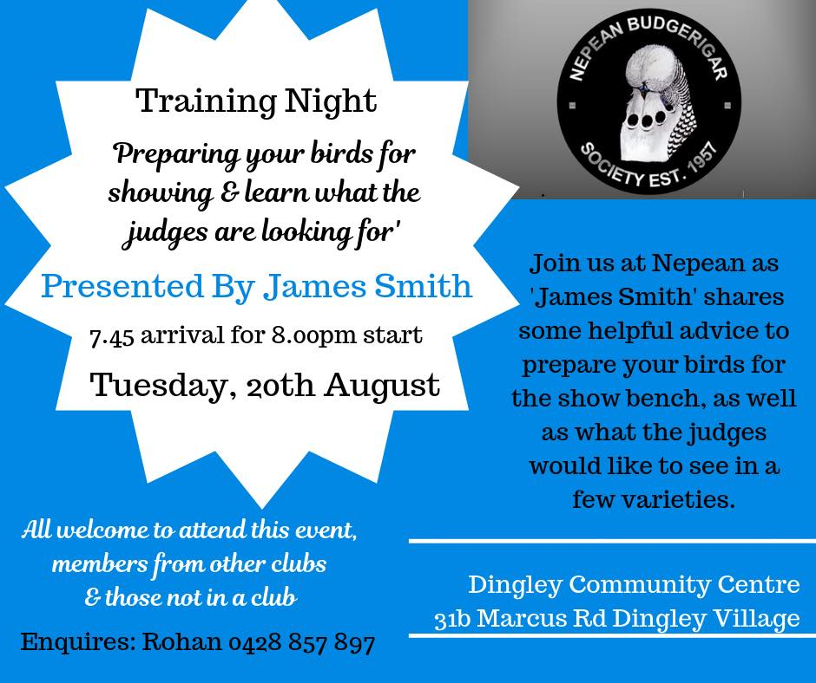
.

Looking forward to what will be an interesting night learning from one of the best in the field!
Please feel free to let your friends know about this event and bring along anyone else you think might be keen to learn. Open to Nepean club members, members from other clubs, and those with an interest in the hobby. And as always, a cuppa and chat to finish off the night.
At the Dingley Community Centre, Tuesday 20th August, 7.45 arrival for 8pm sharp start.
Any queries, call Rohan on 0428857897
Look forward to seeing you there!

This Month's Article
Budgerigar Diseases
Courtesy of Herb Gulvosen, BCV Life Member.
SCALY FACE SYMPTOM - Fungus growth on beak, around eyes, legs & vent TREATMENT - Treat by covering with any ointment (Rawleys man & beast, vaseline or similar. One application every two days should clear it up. Also invermectin one drop on the back of the neck each year will prevent its occurrence.
CANKER SYMPTOM - Listless won`t eat, going light wasting of breast bone: stretching neck upwards hard to breath, cheesy deposits in throat. TREATMENT - Emptryl: 5g per 5ltrs of water for 10 days. Mix fresh every 3 days as it loses its effectiveness after 4 days. Ronivet or sparmix as directed.
SOUR CROP SYMPTOM - Birds vomiting, throwing up seeds. TREATMENT - Condes crystals: mix up a solution in water then dilute into fresh water to obtain a light pink colour. Treat for ten days. NOTE!!! Condes crystals is a poison.
WORMS SYMPTOM - Going light including a weakness and emaciation, severe loss of condition, lowered production and perhaps diarrhoea. TREATMENT - Nilverm or aviverm 3% solution in water 10/12ml in a litre of water or as manufacturers directions. Give second dose 28 days later. There are many more worming mixtures on the market to choose from.
ENTERITIS SYMPTOM - Green diarrhoea, stained green around the vent area. Usually from mice. Also a milder type. TREATMENT - Terrimcin: 1/2g per litre of water. Or as directed depending on strength. Treat for ten days. Biomav B 1 level teaspoon per 100ml of water
COCCIDIOSIS SYMPTOM - Droppings brick red due to massive internal bleeding microbe burrows into stomach lining. Birds usually die within 4 to 5 days. TREATMENT - Sulphonamide drugs Sulphaquinoxaline (Embazine): Tolturazil (Baycox): Purley Coccidial: Mibriausen: Trimidine: Trimsul: Trimethoprim/Sulphonamide anti biotic as well as coccidial: Dosage 4g per 5ltrs of water for 5 to 10 days. Change daily.
PSITTACOSIS (Parrots` Disease). TREATMENT - Oximav B Replaced by Doxycline: Baymil and Psittavet. Dosage as directed depending on strength. AIR SACK MITE SYMPTOM - Asthma type wheeze TREATMENT - Place bird in cage and cover cage with cloth. Lift corner of cloth and spray for 2 seconds with Pea Beau, Mortine or similar spray. Leave covered for 10 seconds.
RED MITE AND BIRD LICE TREATMENT - Invermectin one drop to the back of the neck once a year. Sprays: Pea Beau, Mortine: Bio-mal: Slay etc. Spray birds, perches, cracks & crevices. Dusting powders as for sprays
MEGABACTERIA (Avian Gastric Yeast) SYMPTOM - Can be diagnosed from droppings. Diarrhoea weight loss fluffy & quiet. TREATMENT - Control with citric acid 5gms in 5ltrs of water. You can also use citrus fruit. Treatment use Amphotericin B. Megabac S. fungilin.
FRENCH MOULT SYMPTOM - Chicks lose feathers in or after leaving nest. In severe cases they fail to grow any feathers, except for some down feathers. The virus hides in the cells of the immune system. TREATMENT - Prevention is the best treatment. Clean bird room, breeding cages nest boxes with a solution containing sodium hypochlorite (Domestos or similar product). Using this cleaner will reduce the incidence of french moult by 95%.

Do you have anything bird related for sale you would like to advertise in our newsletter? Please email mim on info@nepeanbudgerigarsociety.org with a short description, and a image if you have one. Also please feel free to email through any news, information or tips you think may be of interest.

An oldie, but a goodie…

A man drives to a gas station and has his tank filled up. The gas pumper spots two penguins sitting in the back seat of the car. He asks the driver, "What's up with the penguins in the back seat?"
The man in the car says "I found them. I asked myself what to do with them, but I haven't had a clue."
The clerk ponders a bit then says, "You should take them to the zoo." "Hey, that's a good idea," says the man in the car and drives away.
The next day the man with the car is back at the same gas station. The clerk sees the penguins are still in the back seat of the car. "Hey, they're still here!

I thought you were going to take them to the zoo." "Oh, I did," says the driver, "And we had a swell time. Today I am taking them to the beach."

Nepean Budgerigar Society Club Events July – December 2019

July Mid year lunch social get together. Sunday lunch 14th July
Dingley Hotel 338 Boundary Rd Dingley @12pm
August 20th Training night – Dingley Community Centre @ 7.45pm. ‘ ‘Getting your birds show ready’ with guest speaker James Smith
August 31st UBC state selection & social BBQ Saturday @ 11am
Venue - Johns factory Poly Wheel 42 Nicholas Dve Dandenong Sth
September 8th UBC State Show Venue – Carwatha College, Noble Park
October 15th Training night - Dingley Community Centre @ 7.45pm. Topic TBC
November 19th Committee meeting (for committee members)
December Christmas get together – Date and Venue TBC

BCV Club Shows
September 22nd Geelong UBC Show
October 12th United UBC Show
October 13th Goulburn Club Champ
October 19th Dandenong Club Champ
October 26th SW Vic UBC
October 27th Eastern Club Champ
November 3rd Clyde Club Champ
November 10th Western Suburbs Club Champ
November 16th Colac UBC Show

Club Contacts
Emails – info@nepeanbudgerigarsociety.org Venue – Dingley Community Centre
President: John Freeman 0419 146 911 31b Marcus Rd, Dingley Village
Secretary: Mim McQualter 0421 085 974
Treasurer: Rohan McQualter 0428 857 897

